

ATAR Biology

Unit 2: Topic 4

Week 31 Digestive Systems

© SIDE

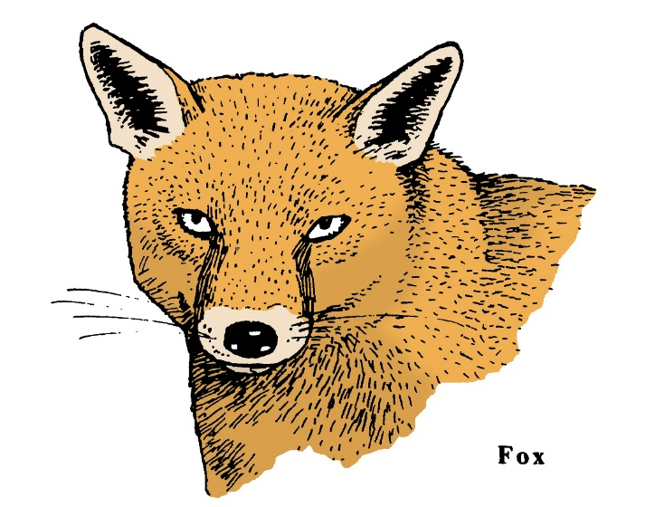

Student Study Notes

Unit Content
- In animals, the acquisition and processing of nutrients is facilitated by the structure of the digestive system; animals may have a gastrovascular cavity with one opening or a specialised alimentary canal with two openings; specialisation of alimentary canals is related to diet, for example, herbivores and carnivores.

Structural organisation in multicellular organisms
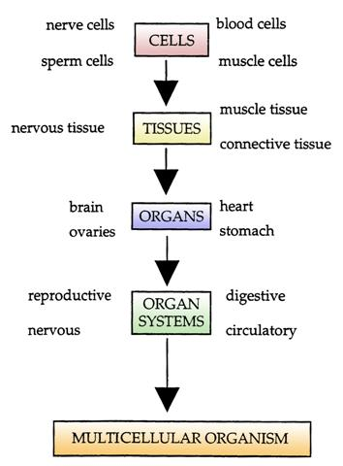

© SIDE

Cells, tissues and organs
In the plant, or animal body, most cells are specialised to perform certain functions.

Cells
Cells are the basic unit of life and are usually specialised. For example, in animals, muscle cells are specialised for movement and a nerve cell carries messages. In plants, root hair cells take in water while leaf cells trap sunlight.

Tissues
Specialised cells grouped together to perform a common function are known as tissues.
Organs
Different types of tissue combine together to form organs. For example, the heart is an organ made from muscle tissue. Several organs combine to form a system.

Organs
Different types of tissue combine together to form organs. For example, the heart is an organ made from muscle tissue. Several organs combine to form a system.

The acquisition and processing of nutrients
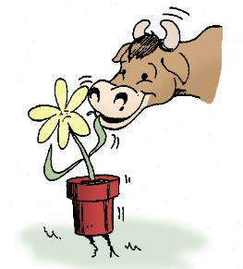
In animals, the acquisition and processing of nutrients is facilitated by the structure of the digestive system. Animals, such as jellyfish and coral, have a gastrovascular cavity with only one opening. Arthropods, molluscs, annelids, echinoderms and chordates have an alimentary canal with two openings: the mouth and the anus.
Heterotrophs cannot produce their own food. Heterotrophs can be grouped according to the way they acquire nutrients.
Herbivores obtain nutrients by eating plants. Grazing animals and leaf eaters such as kangaroos and koalas are herbivores.
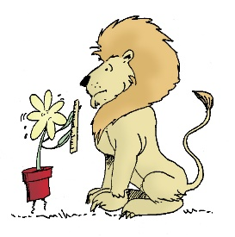
Carnivores obtain nutrients by eating other animals.Predators and scavengers such as crocodiles and wedge-tailed eagles are carnivores.
© SIDE
Omnivores obtain nutrients by eating plants and animals.Pigs, primates and many birds including honeyeaters are omnivores.

Digestion
Digestion is a process where food is gradually broken down into small pieces.
Complex organic compounds produced by plants are too large to pass through animal cell membranes, so they need to be broken down until they are small enough to be absorbed.
The process where organic compounds are broken down for absorption is called digestion.
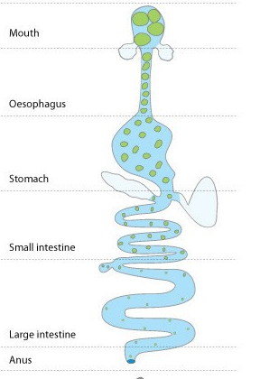
The digestive system
Most animal digestive systems consist of an alimentary canal which runs through the body from the mouth to the anus.
Although animals obtain nutrients in different ways, the digestion process is similar and occurs in a series of steps as outlined below:
Ingestion
Ingested food enters the mouth where it is mechanically and chemically broken down by chewing and the secretion of saliva. The result is a moist ball of food, called a bolus, that can be easily swallowed.
© WestOne
Digestion
This is the process of breaking down organic compounds into molecules, small enough to pass through the gut and enter cells of the body.
Absorption
The simple molecules produced by chemical digestion of food include amino acids, simple sugars, such as glucose, and fatty acids, which can be absorbed through the gut wall and into the blood for distribution around the body to all cells. Some water is also absorbed through the gut walls.
Egestion
The remaining undigested material is eliminated from the body as faeces.

Specialisation of alimentary canals
Specialisation of alimentary canals is related to diet, for example, herbivores and carnivores

Herbivores
Plant material such as cellulose is difficult to digest yet rabbits, cows, sheep and kangaroos obtain nutrients from a diet of grass.
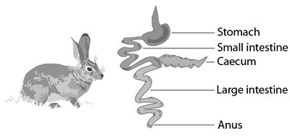
© WestOne
The caecum in a rabbit's digestive system is relatively large and contains bacteria which have the ability to break down cellulose. Cows also have these fermenting bacteria in a four-chambered stomach in much greater quantities. The digestive process is much slower in cows.

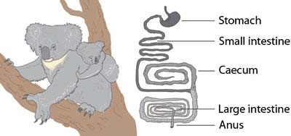
The koala digestive tract has been adapted with the permission of the Australian Academy of Science

Very few animals eat eucalyptus leaves due to the high levels of toxins present and the relatively low energy value. The koala eats eucalyptus leaves exclusively, preferring the succulent young leaves.
Koalas lead a sedentary lifestyle, which enables them to survive on a diet yielding half the energy required by similar-sized placental mammals.
The process of digestion starts with the koala's teeth grinding the leaves into smaller-sized pieces while saliva begins to break down the leaves chemically. After the koala has swallowed the leaves, the toxic substances are broken down in its stomach.
From the stomach, the partially digested food moves into the small intestine where further digestion occurs and nutrients are absorbed into the bloodstream.
The remaining undigested material passes into the relatively large caecum where micro-organisms convert the cellulose cell walls of the leaves into glucose. Eucalyptus leaves contain indigestible lignin which is egested.
In the large intestine, water is extracted. The koala's faeces are like dry pellets. Koala is an Indigenous Australian word meaning 'no water' as koalas rarely drink. The majority of their water intake is from the food they eat and by licking dew or rain from leaves.

Carnivores
Carnivores obtain nutrients by eating other animals. Examples include predator insects such as the praying mantis and dragonflies.

Carnivorous mammals usually have large canine teeth which are used to kill and tear meat.
© SIDE
The carnivore digestive system is shorter and more efficient than in herbivores and produces all the enzymes required for digesting the lipids and proteins of a meat diet.

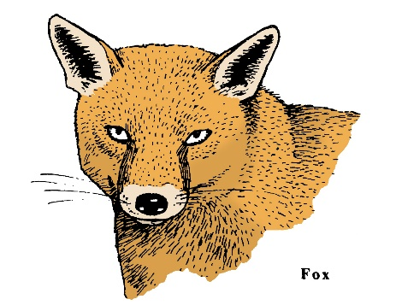
© SIDE

PRACTICE QUESTIONS
1. Give the main function for each part of the digestive system shown below.

Main function

__________________________

__________________________

__________________________

__________________________

__________________________

__________________________
© WestOne

2. Complete the table below comparing the digestive system of herbivores and carnivores.

 | herbivore | carnivore
Examples
Main diet
Digestive system: length
Stomach: size, number
Caecum: size
Aid to digestion

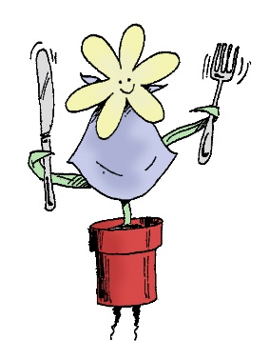
© SIDE
3. Explain the difference between mechanical and chemical digestion.

4. Identify differences in dentition between carnivores, herbivores and omnivores.

5. What is the function of the villi in the small intestine?
- Decrease the amount of exposed surface
- Increase chemical digestion
- To sweep particles through the small intestine with wave-like actions
- Increase the surface area for absorption

6. What is the difference between a gastrovascular cavity and alimentary canal. Identify an organism that possess each type of digestive system.

7. Name and describe the four main roles of the digestive system.

